

**ASSIGNMENT – 3**

COURSE : DEVOPS

Trainer : Mr . MADHUKAR

NAME:A AKSHITHA

Mail id : annabathinaakshitha13@gmail.com

**1 . By using Terraform create an S3 Bucket and upload the file to the S3 bucket ?**

* Log into AWS Account
* After login go to console home page

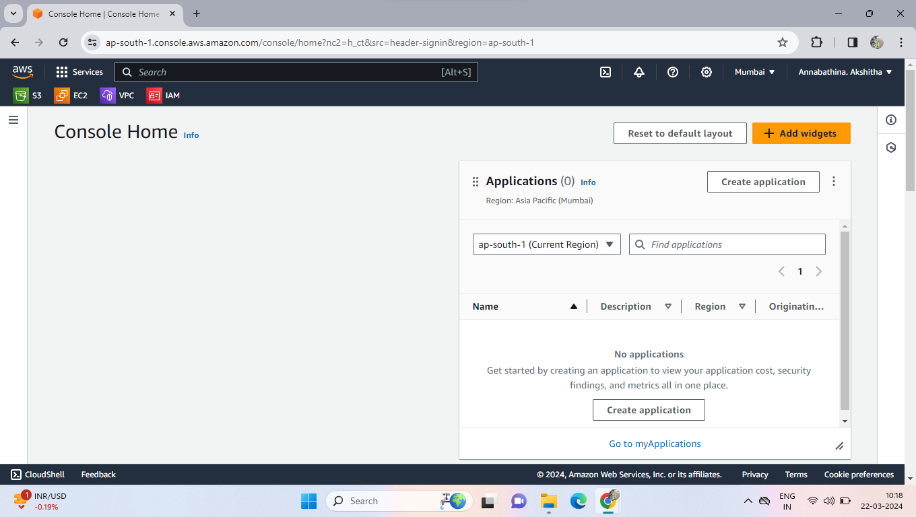

* No go to IAM then create a user and add “**S3”** permissions to created user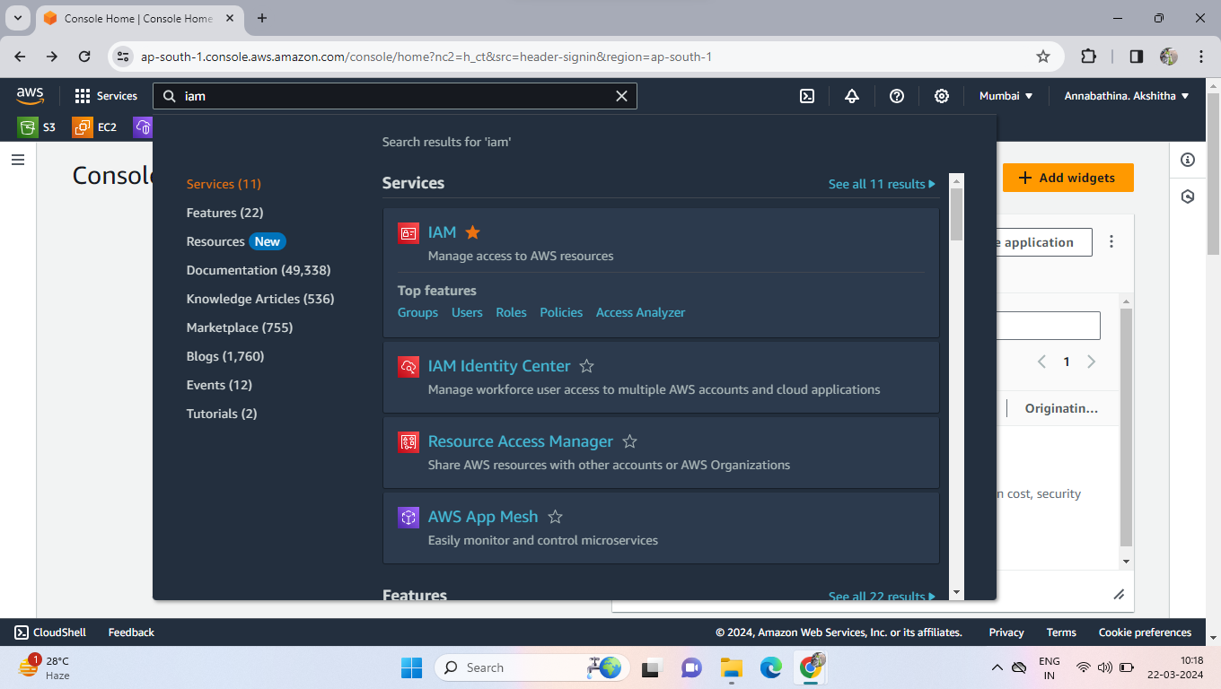
* Now click on users
* Click on create user then enter user name and click on check box of provide user access
* Click on I want create user then we can choose automated password either custom password
* Uncheck the user must create a new password then click on next

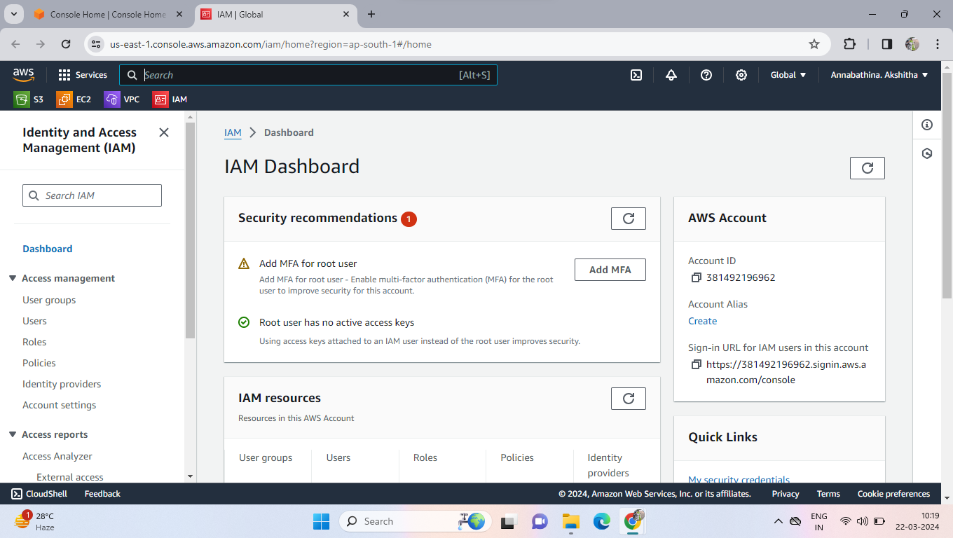

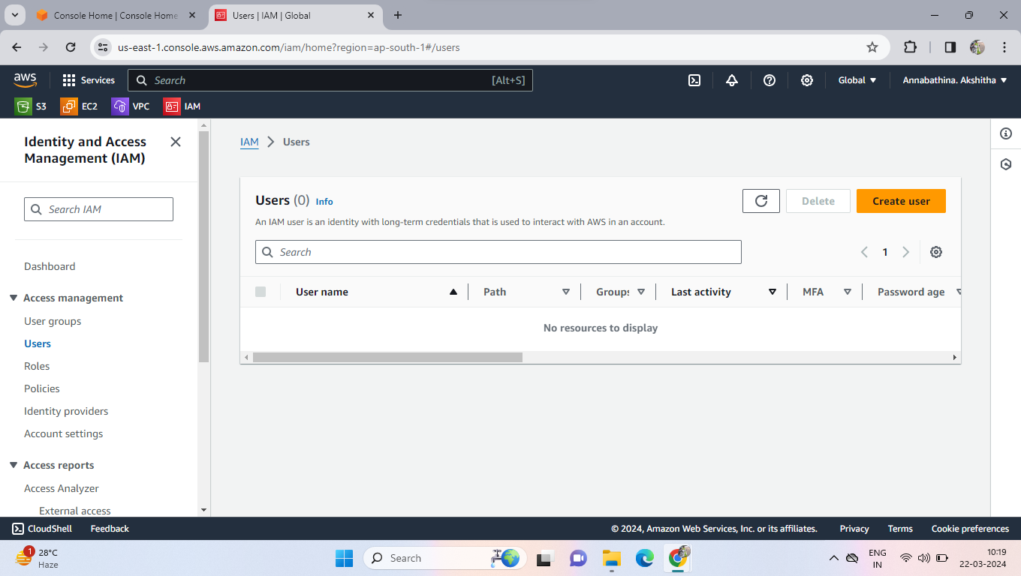

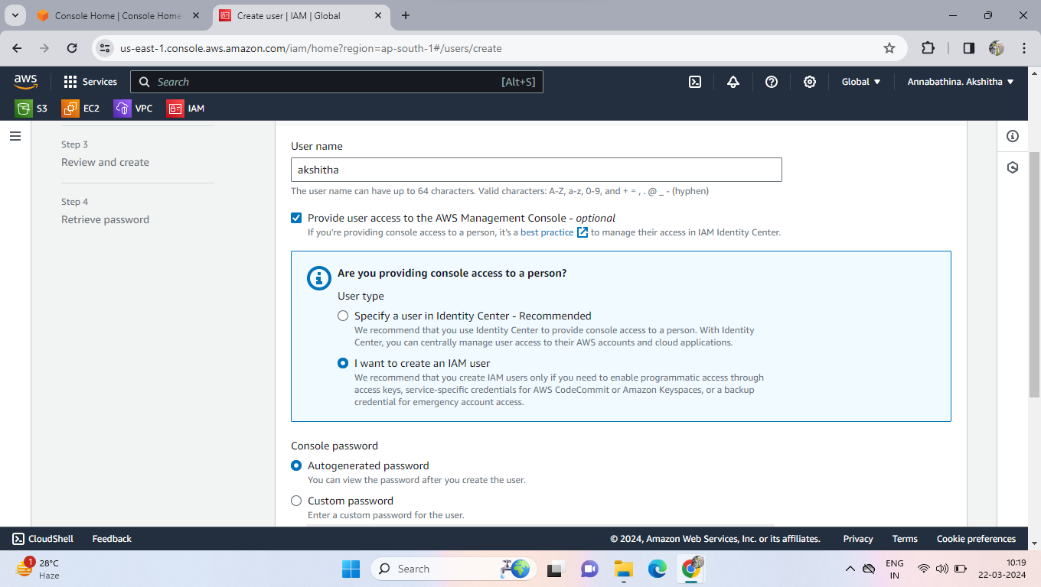

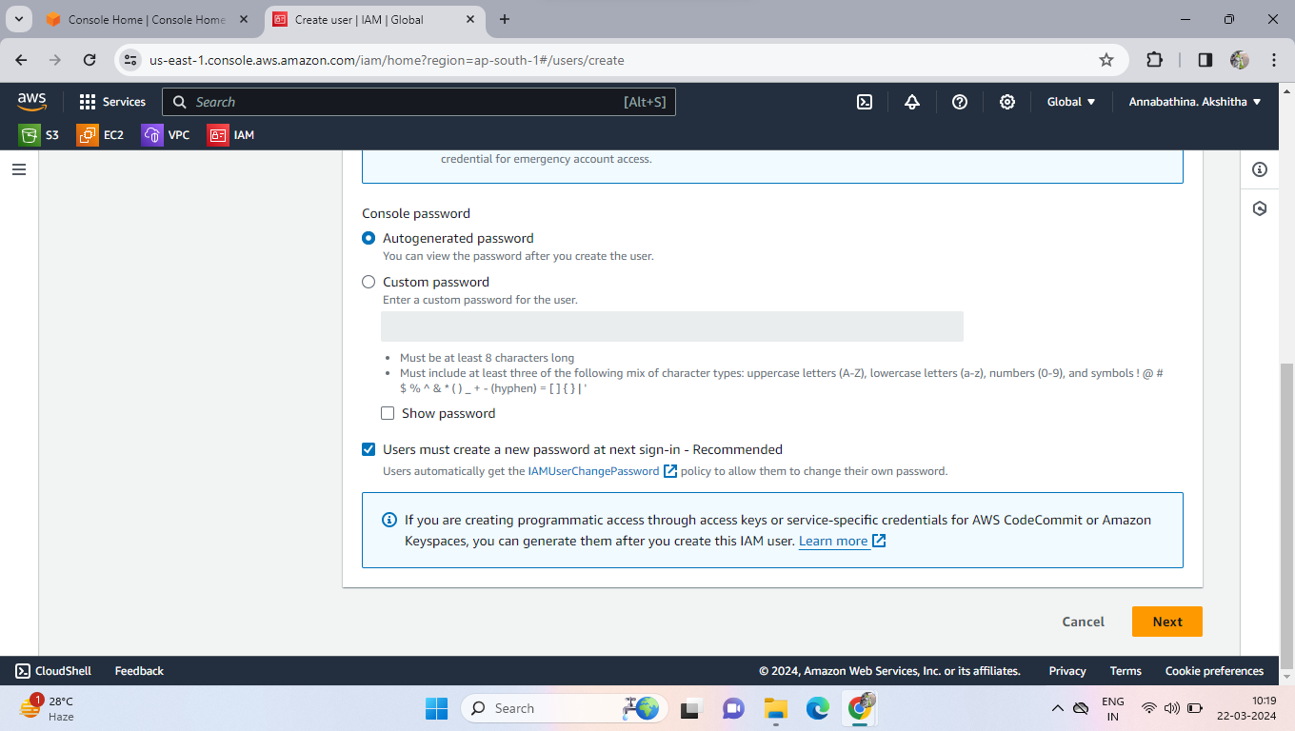

* Click on Attach policy then select s3 full access permission policy then click on next
* Click on Create a user.

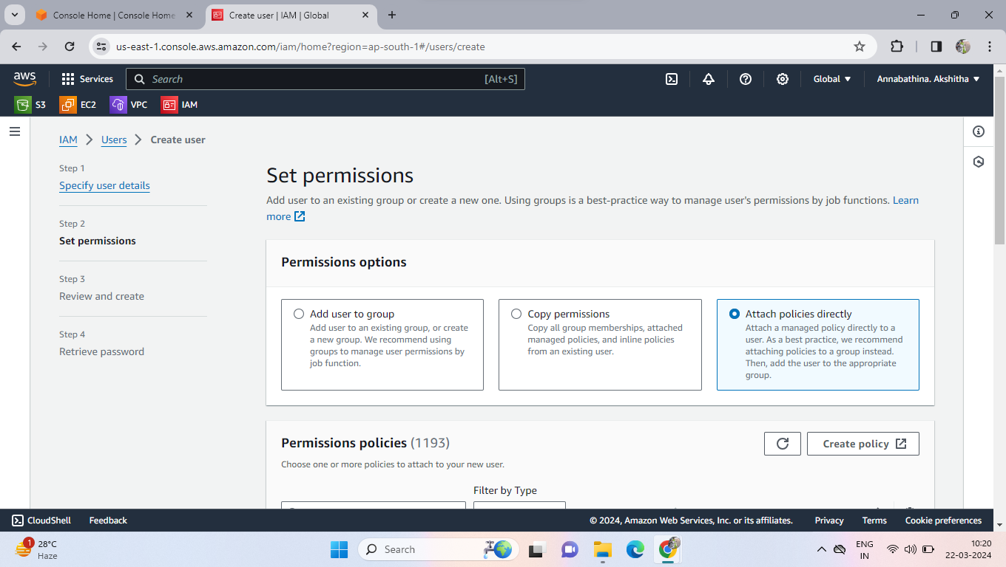

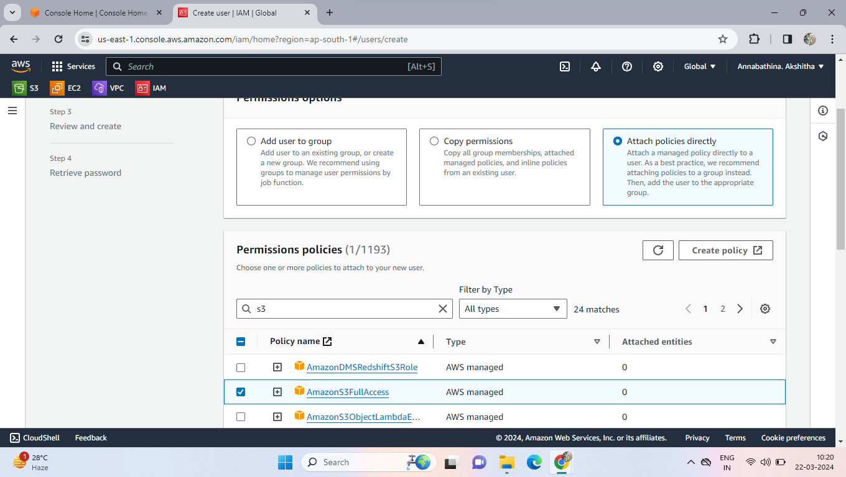

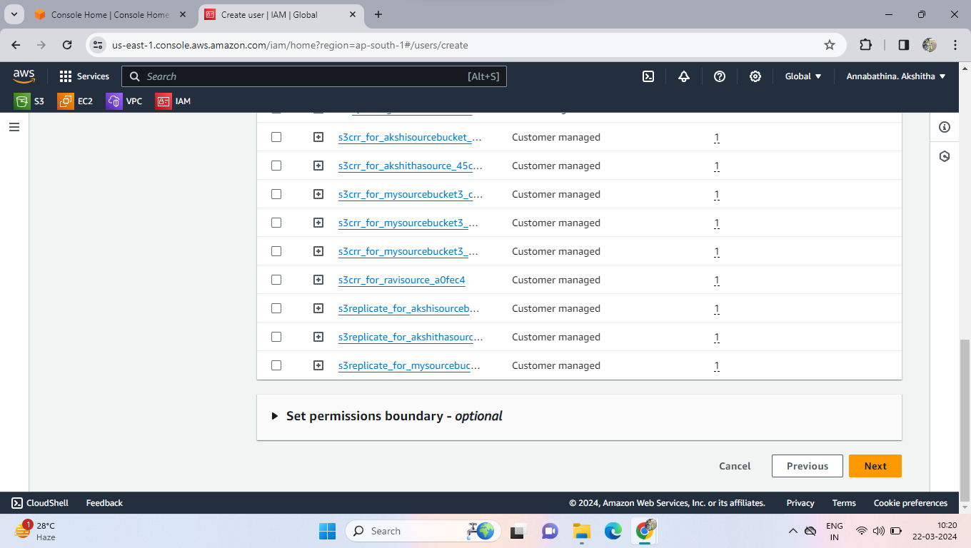

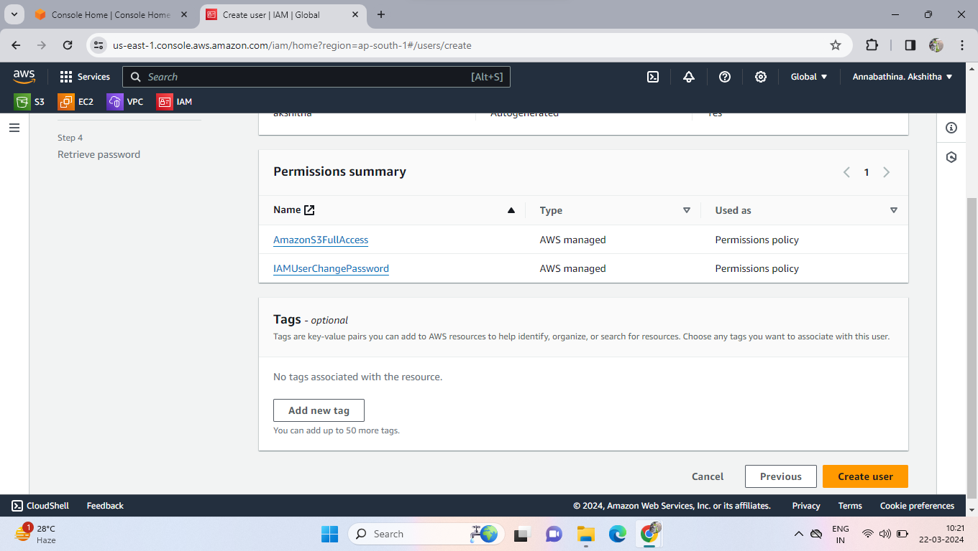

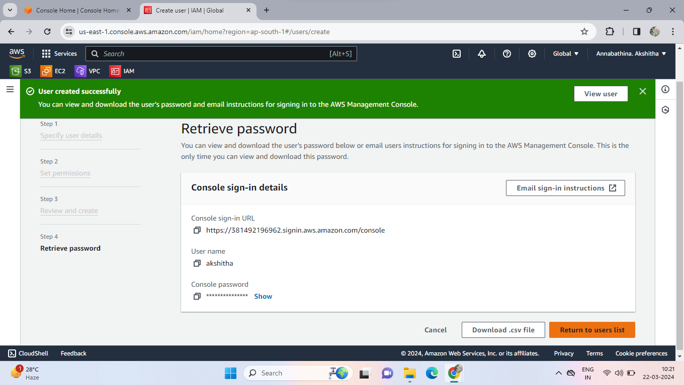

* Now click on created user
* Create a access key for user
* Click on create user and select CLI (Command Line Interface) then click on next enter description then create a access key

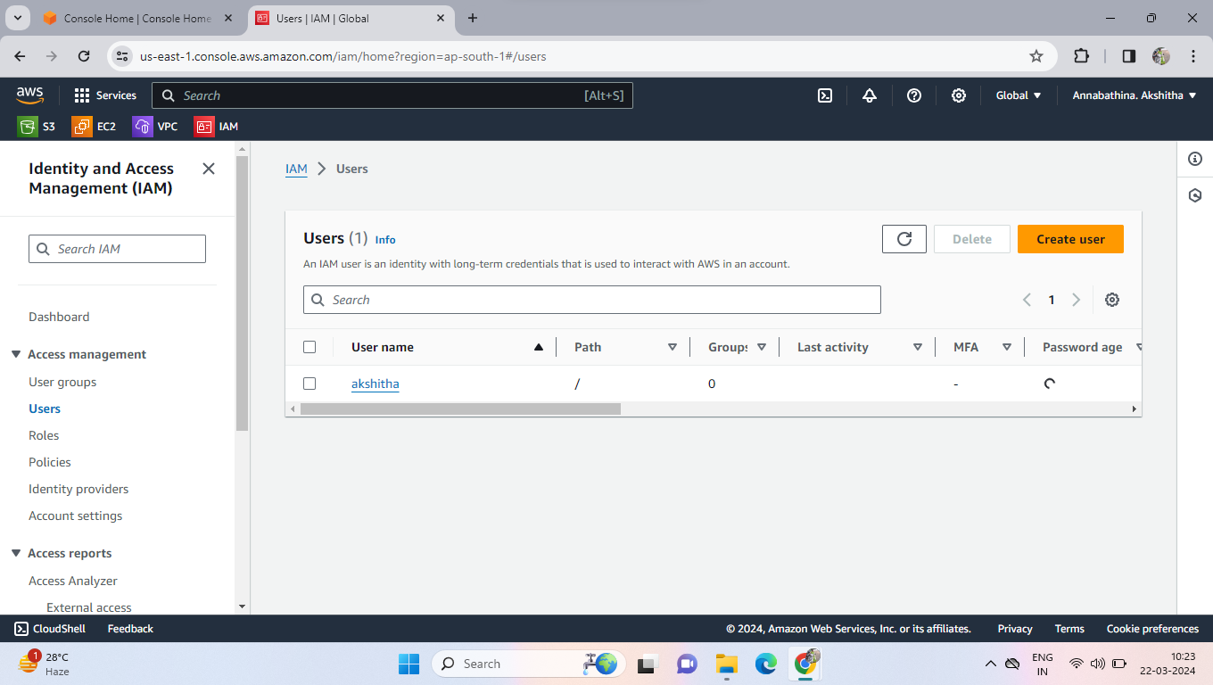

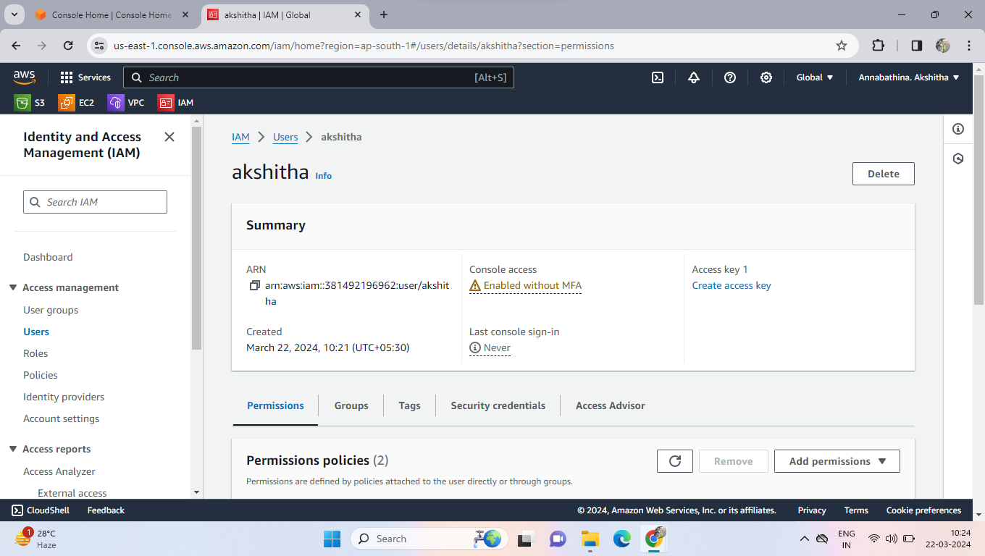

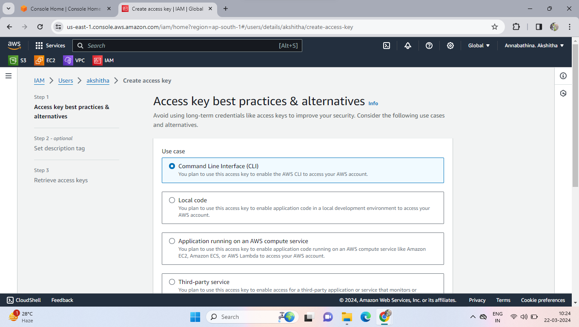

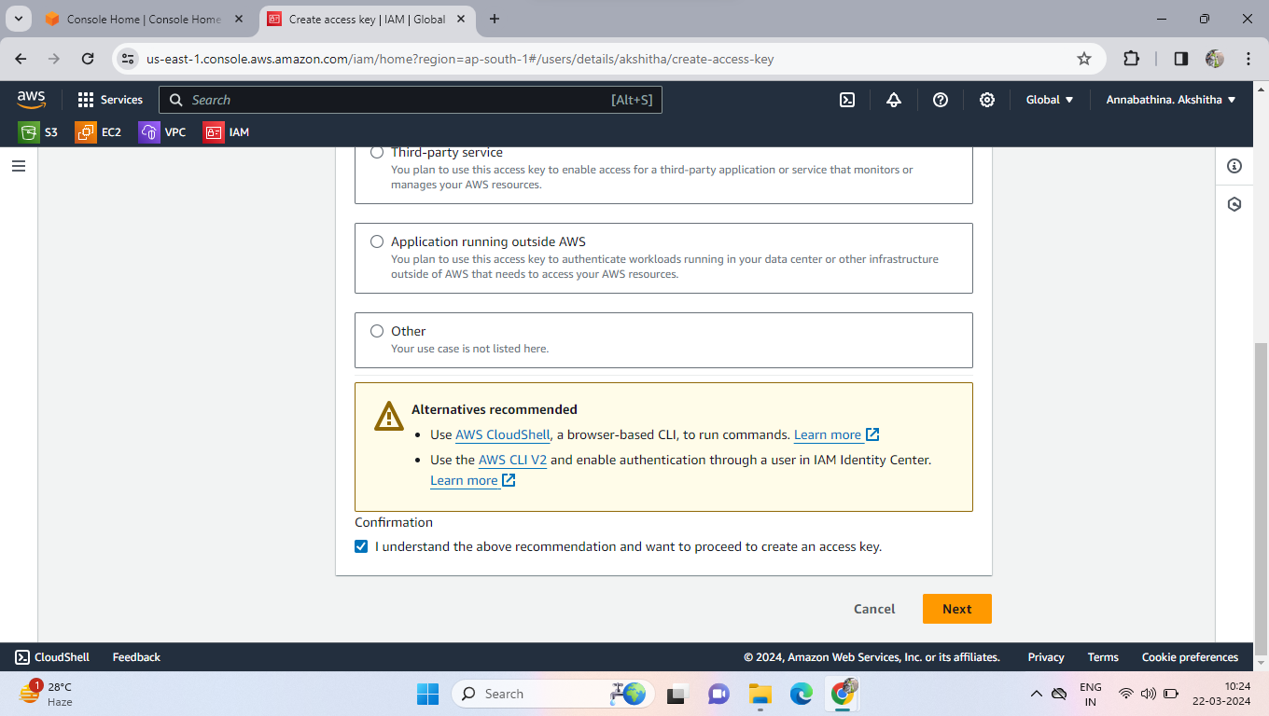

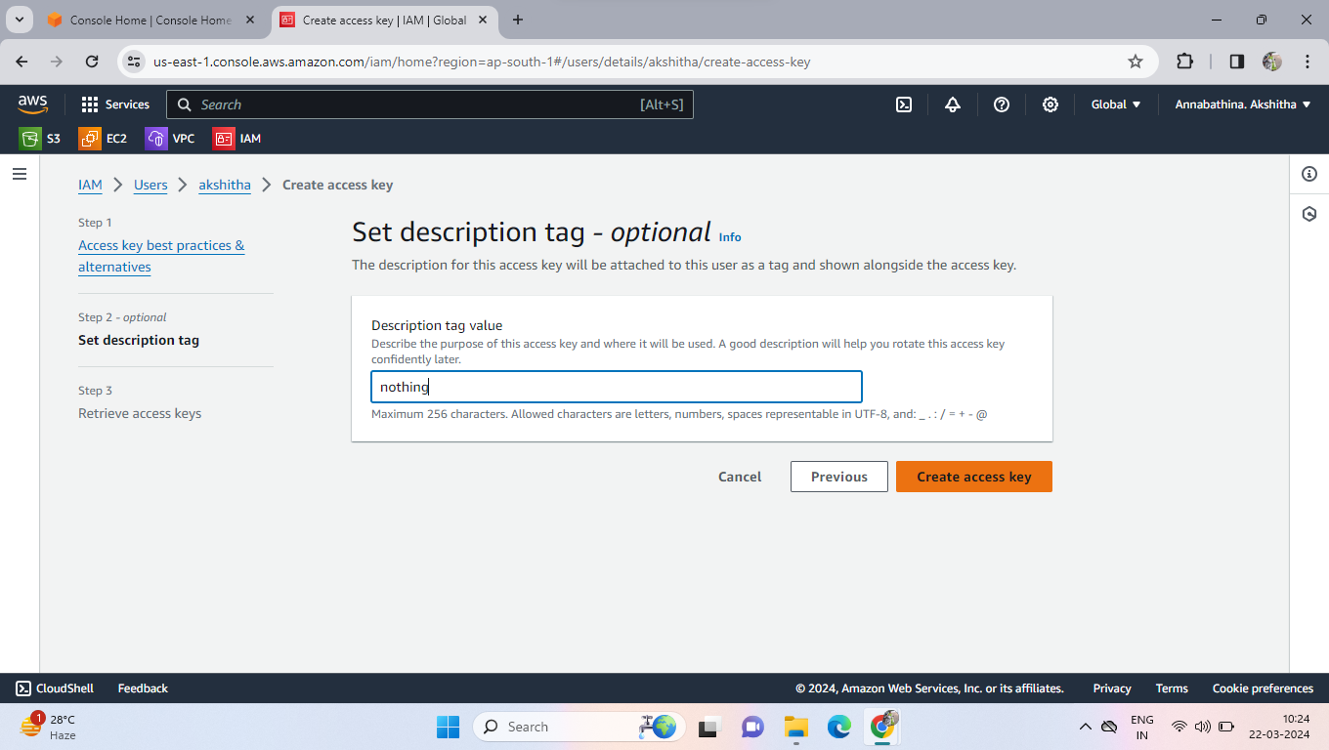

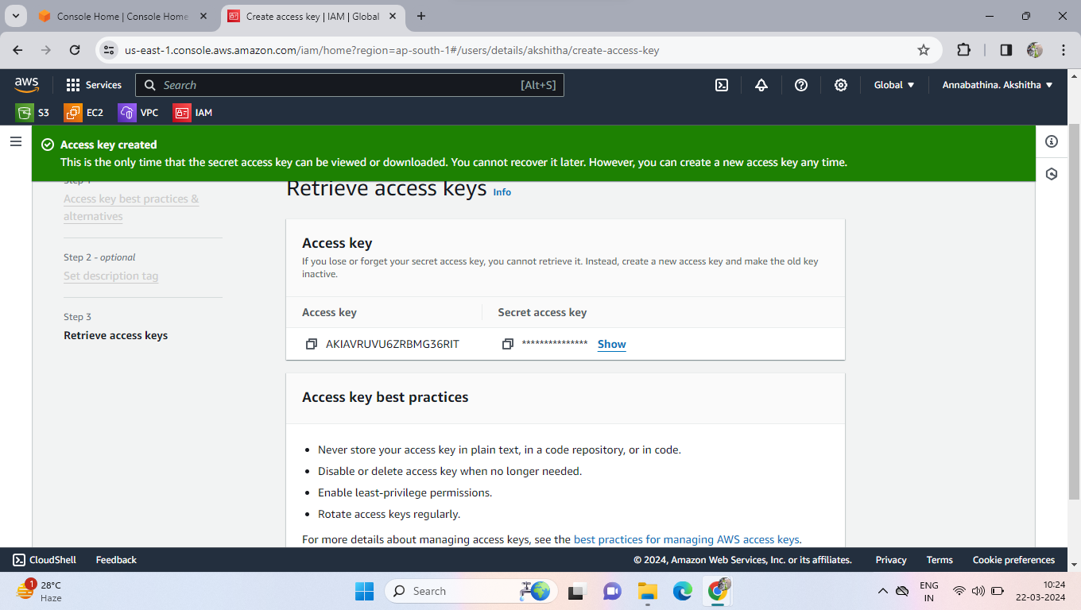

* Now go to EC2
* Create a ec2 instance in ubuntu then connect the ec2 instance

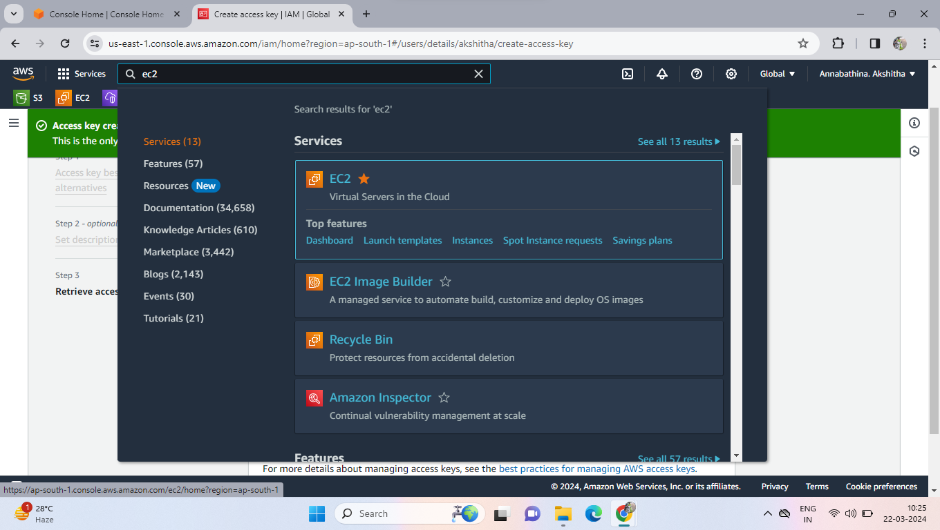

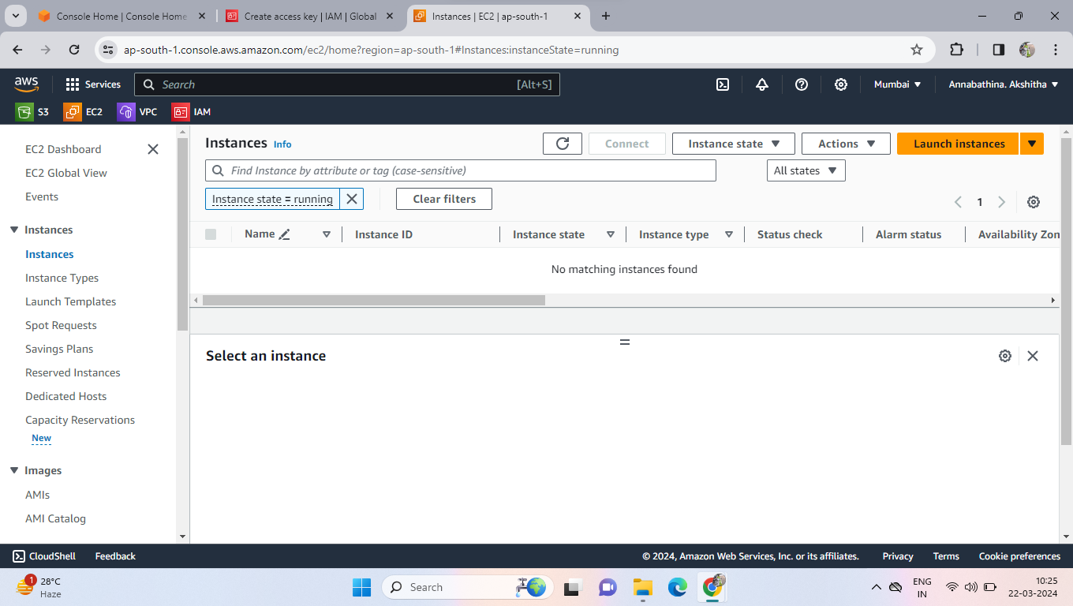

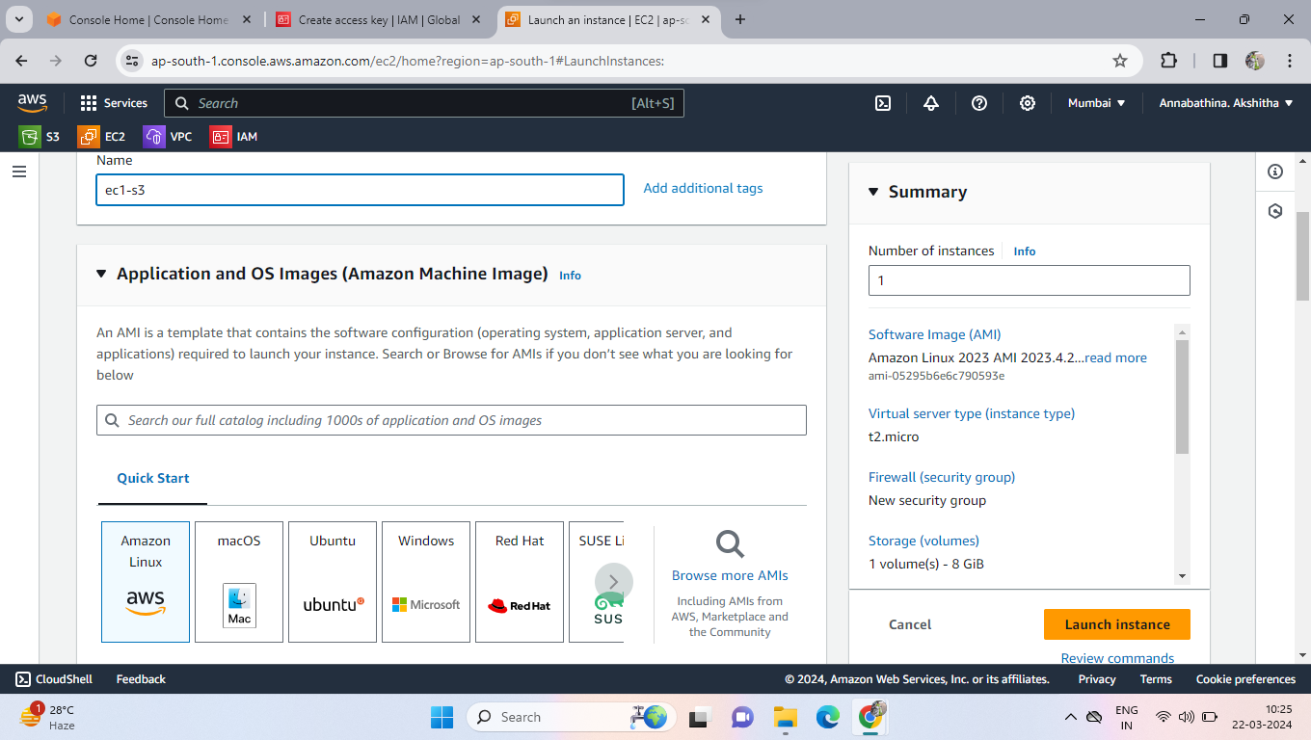

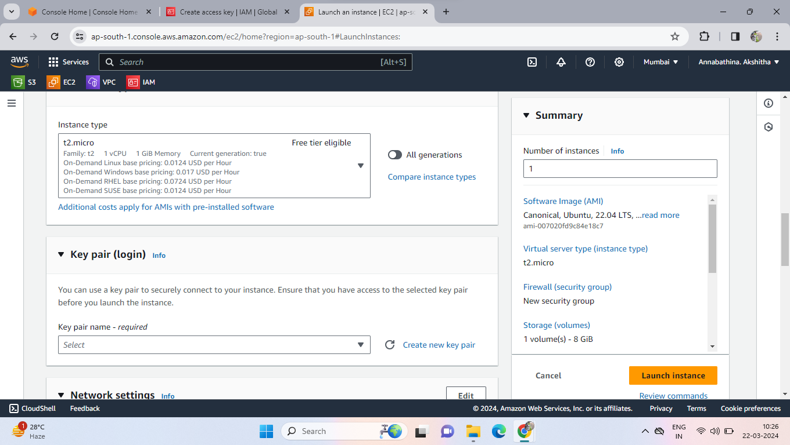

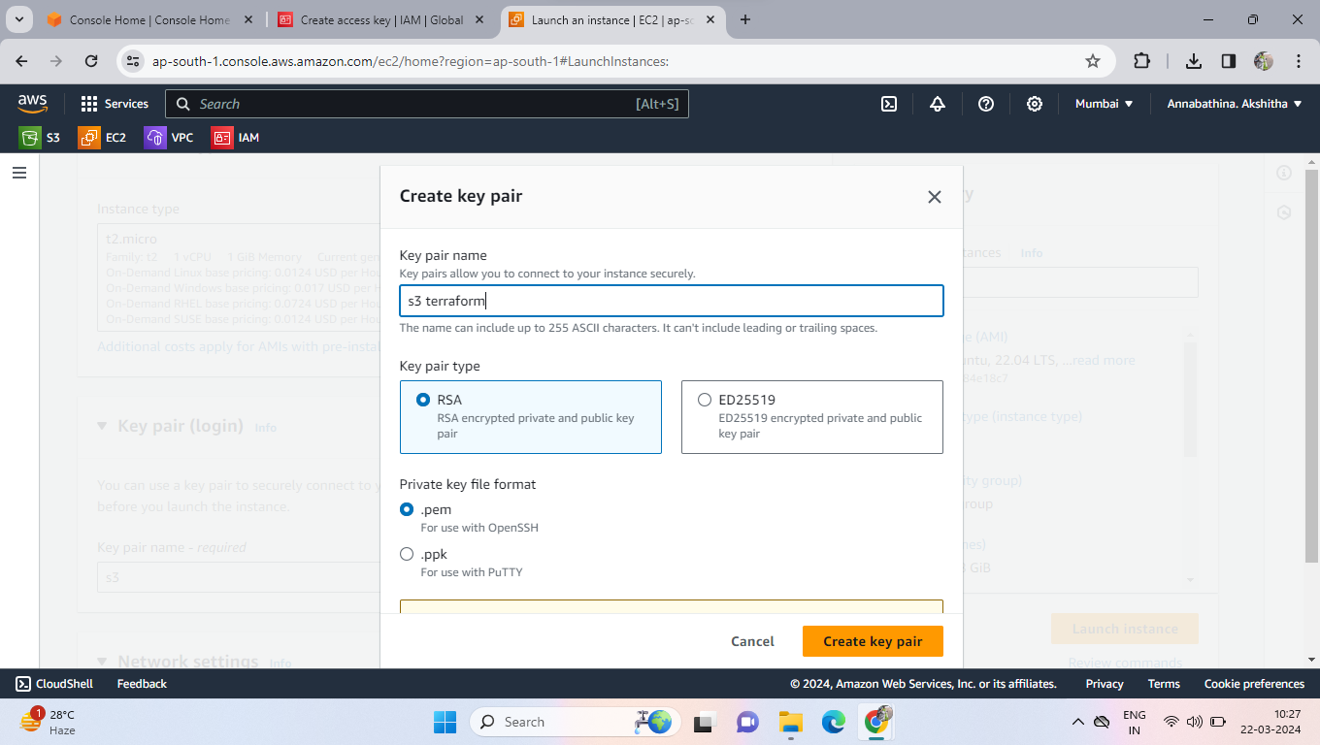

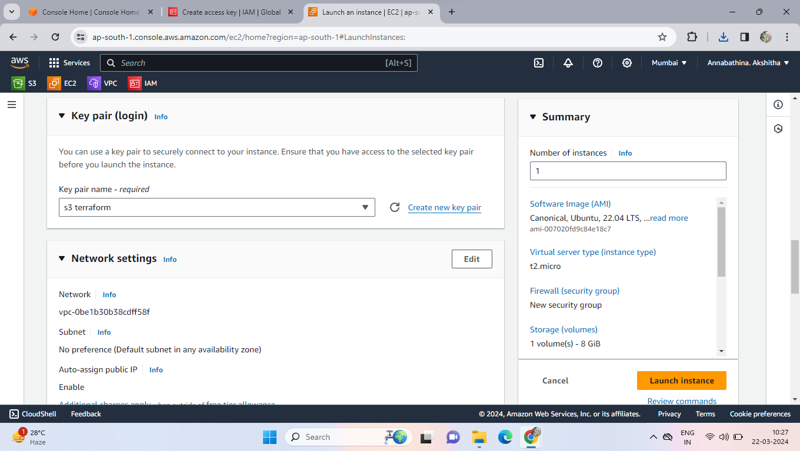

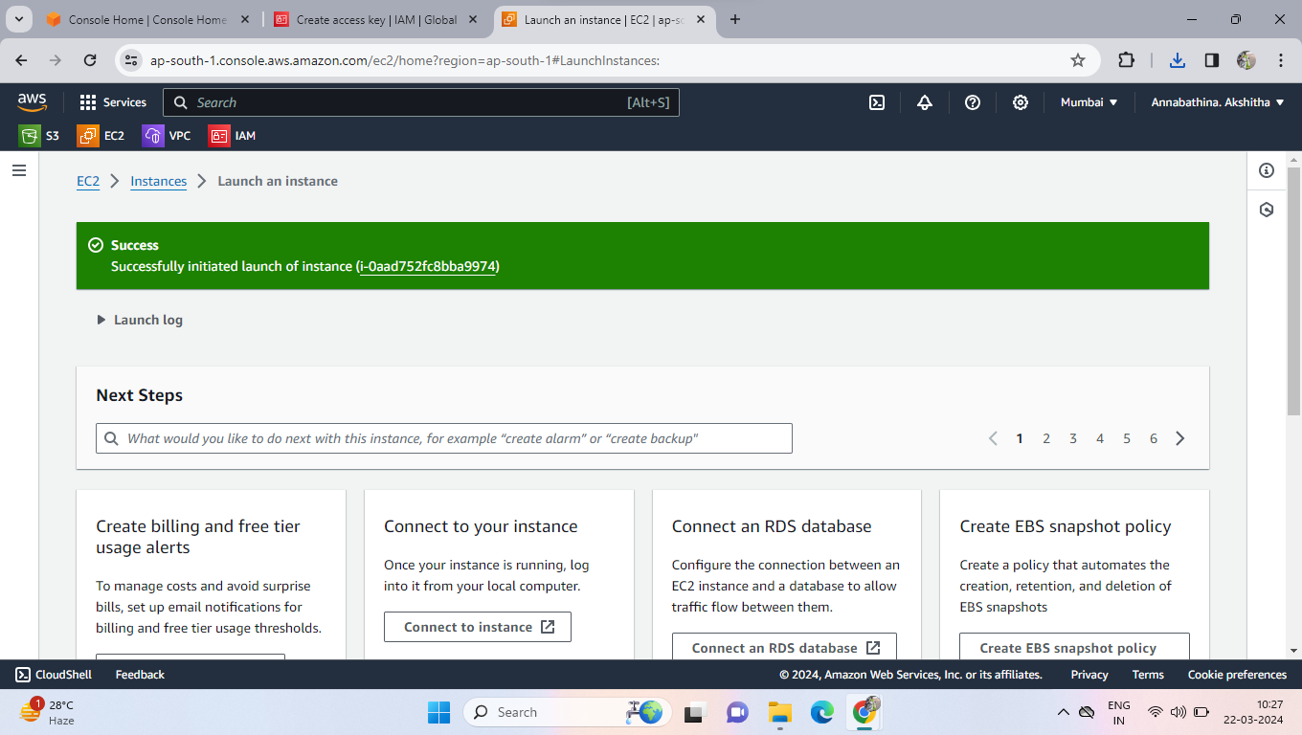

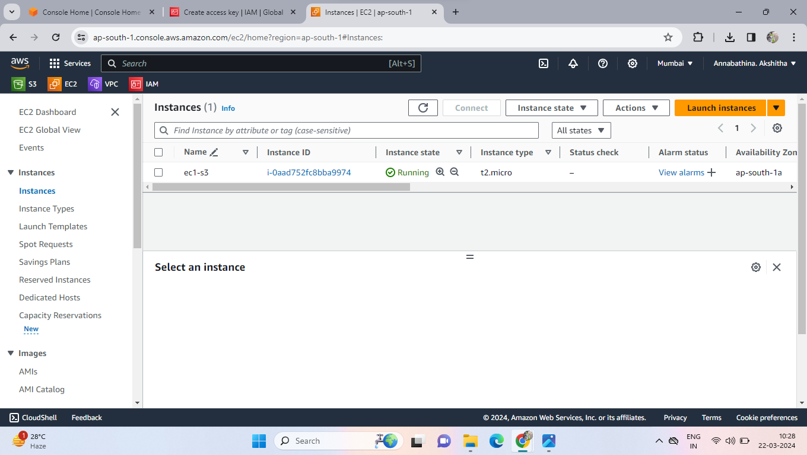

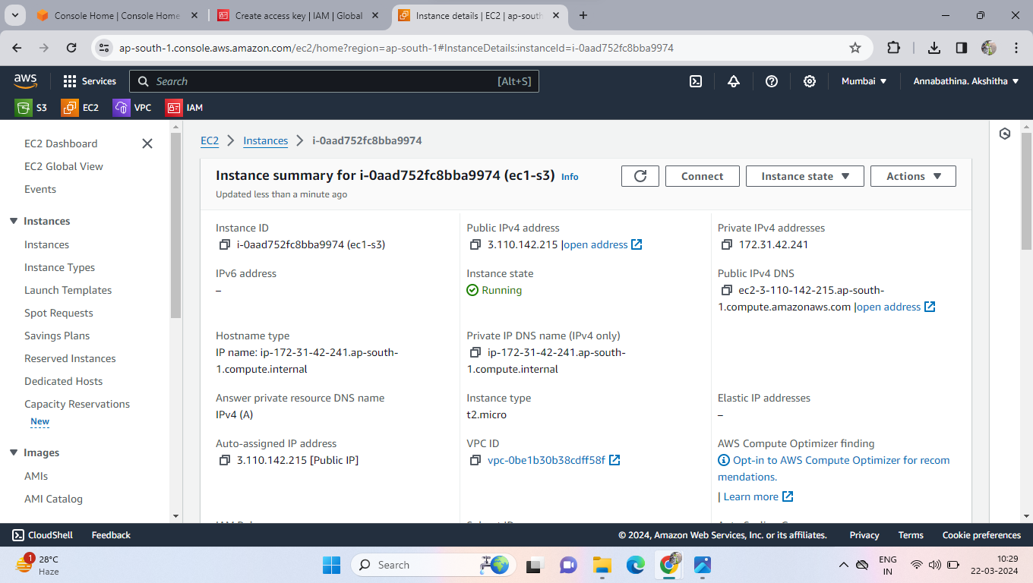

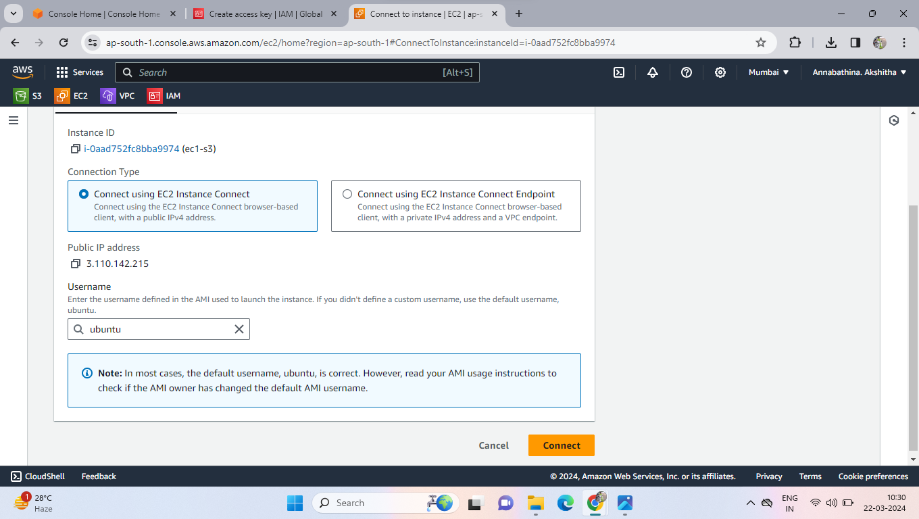

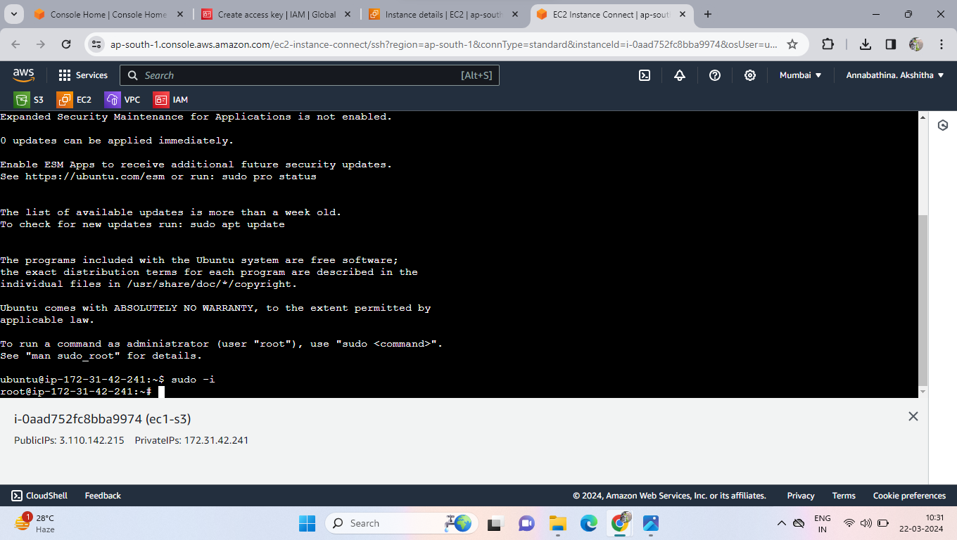

.Now install awscli in ec2 instance commands is

Apt update –y

Apt install awscli –y

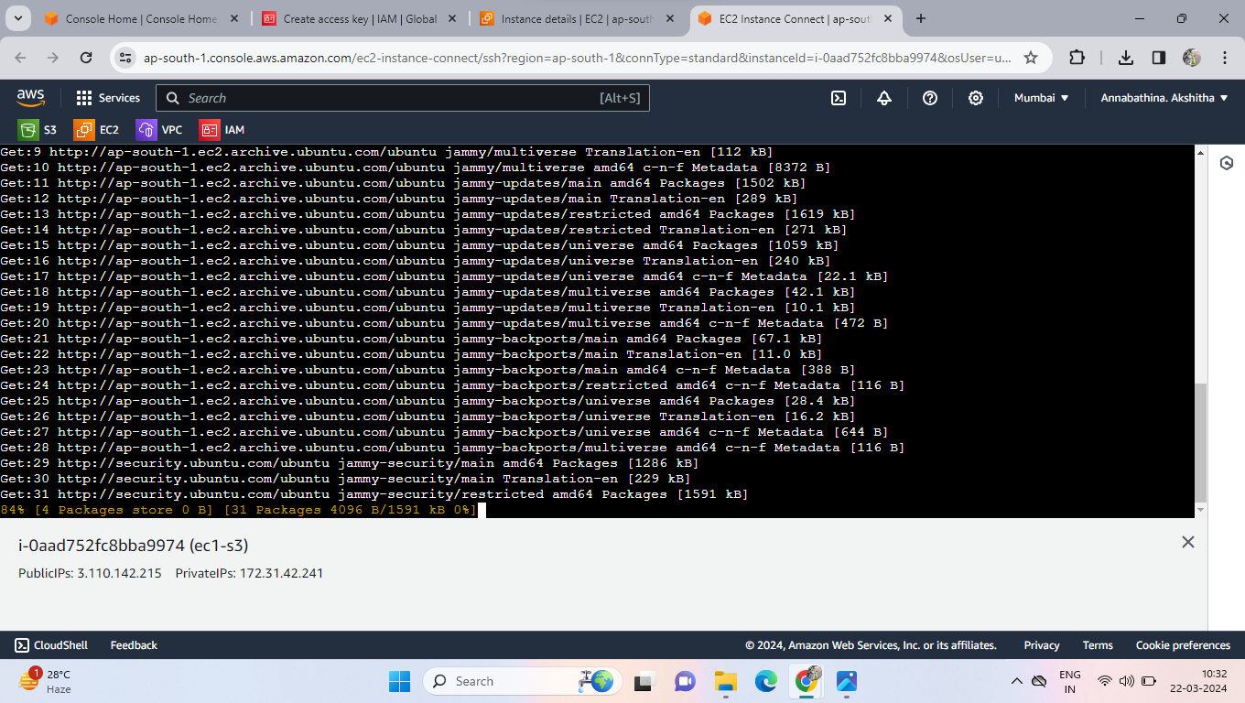

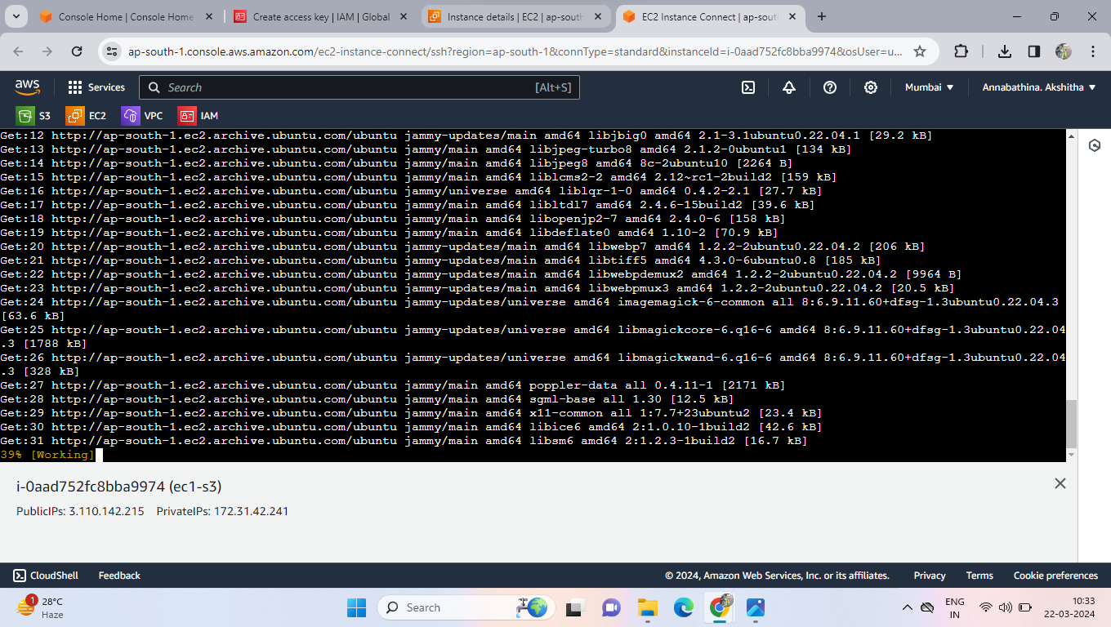

* After Installing awscli then configure the user to awscli

Aws configure

Access key = “”

Secret access key = “”

Default region = “”

Output format = “”

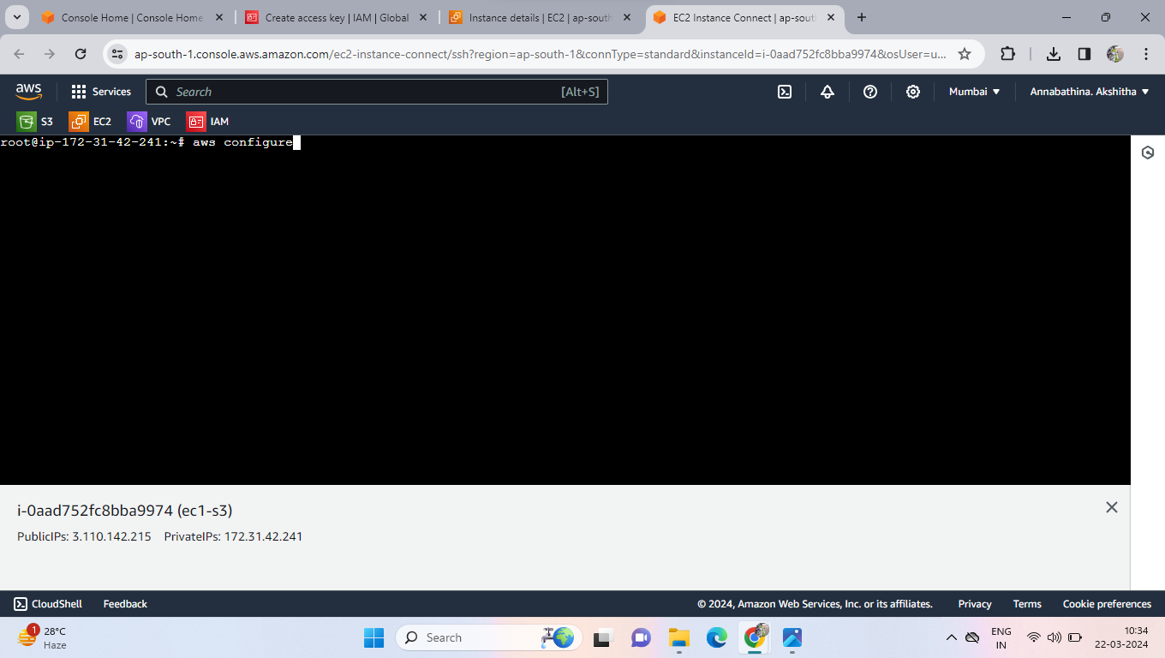

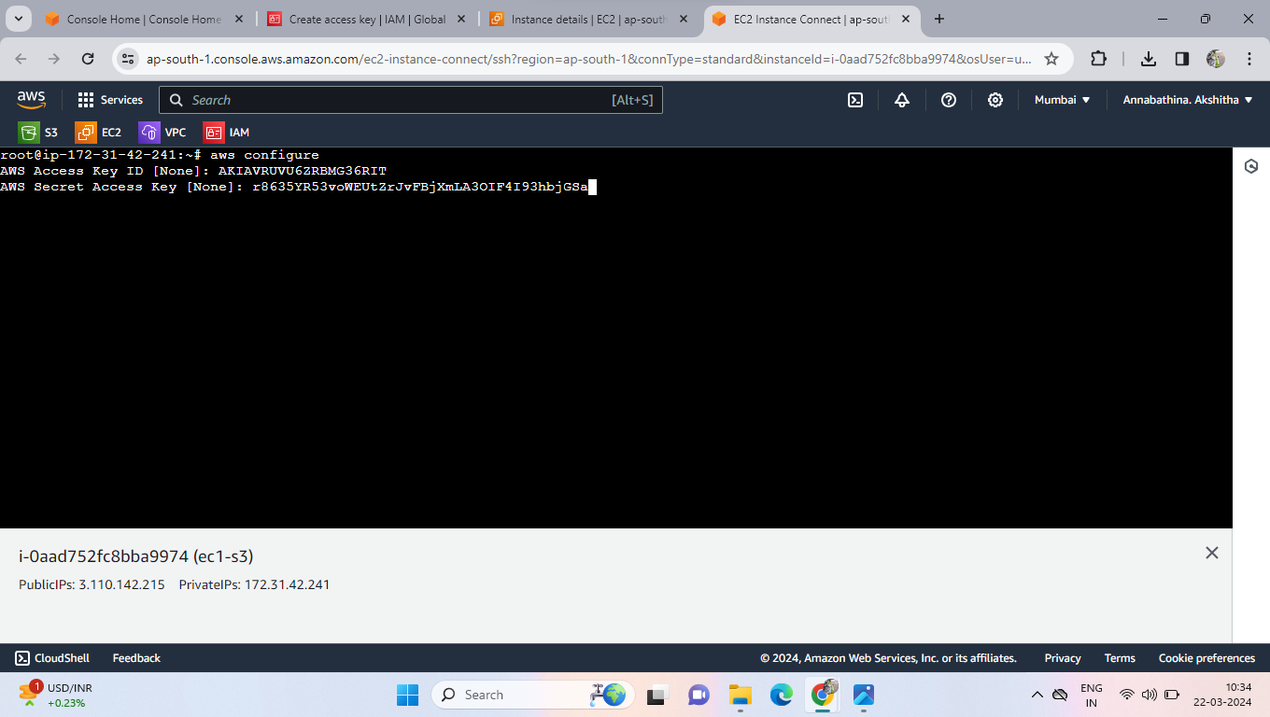

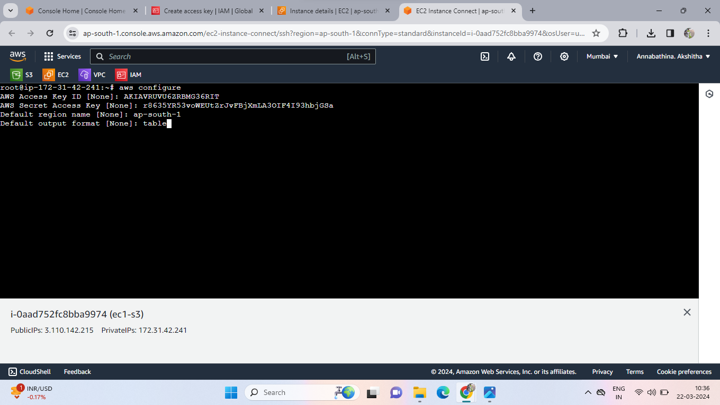

* Now install Terraform
* Copy the terraform install command then paste into the server

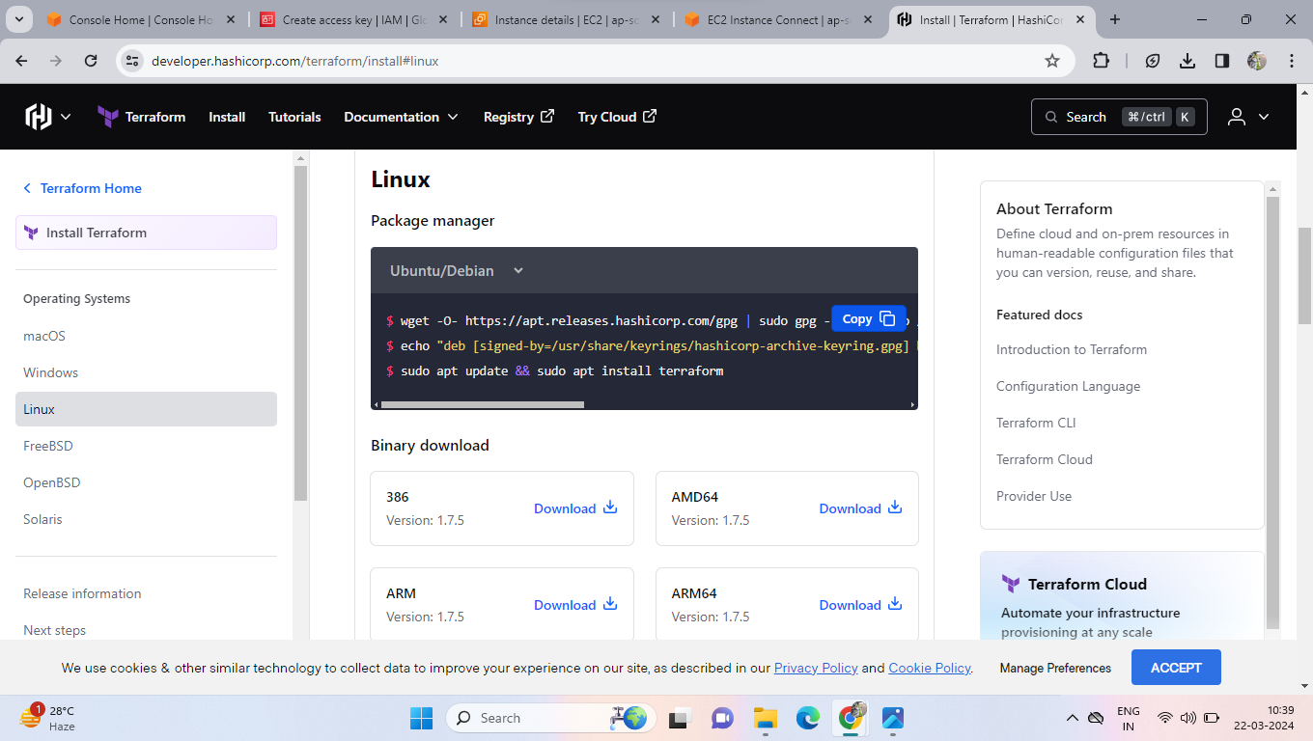

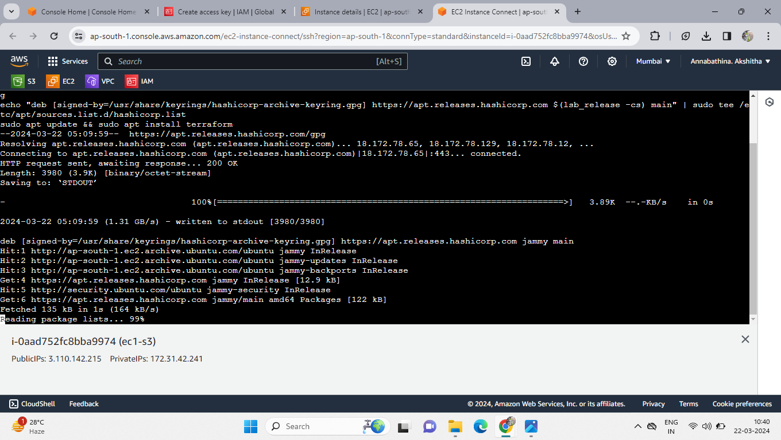

* Now we can change the default names in credentials and config files

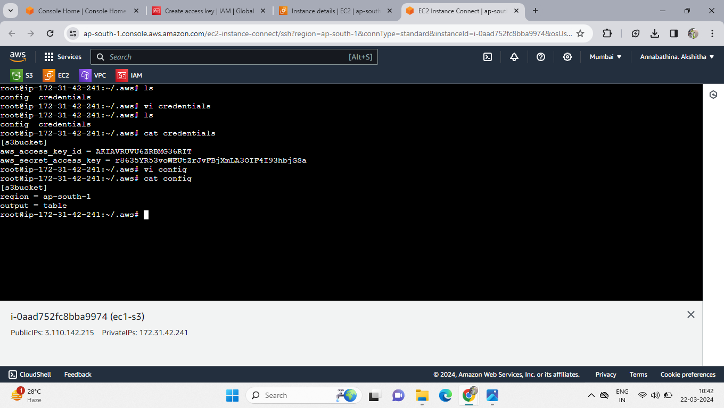

* Now create one directory in that directory write the script of create a s3 bucket
* Create provider block and resource block

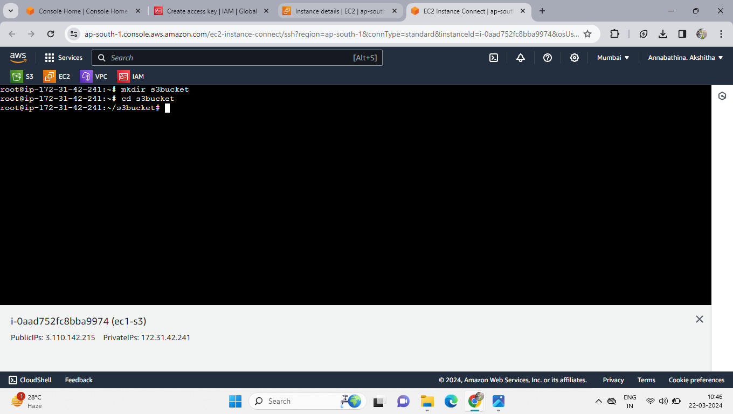

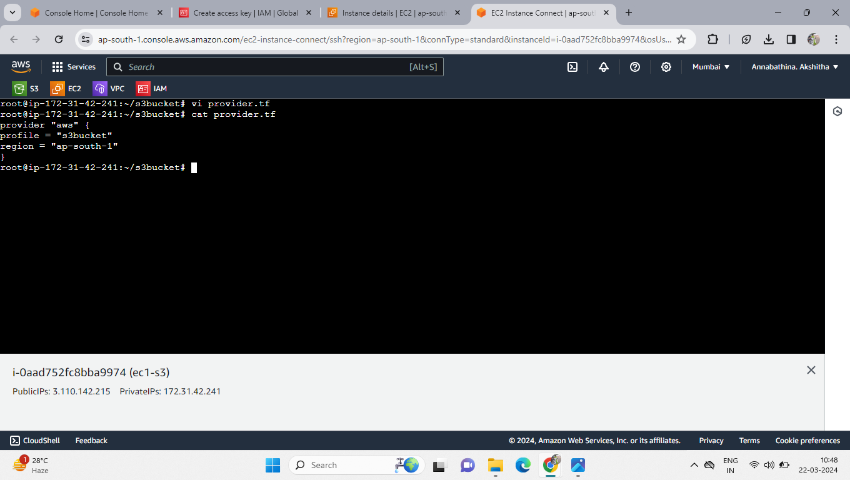

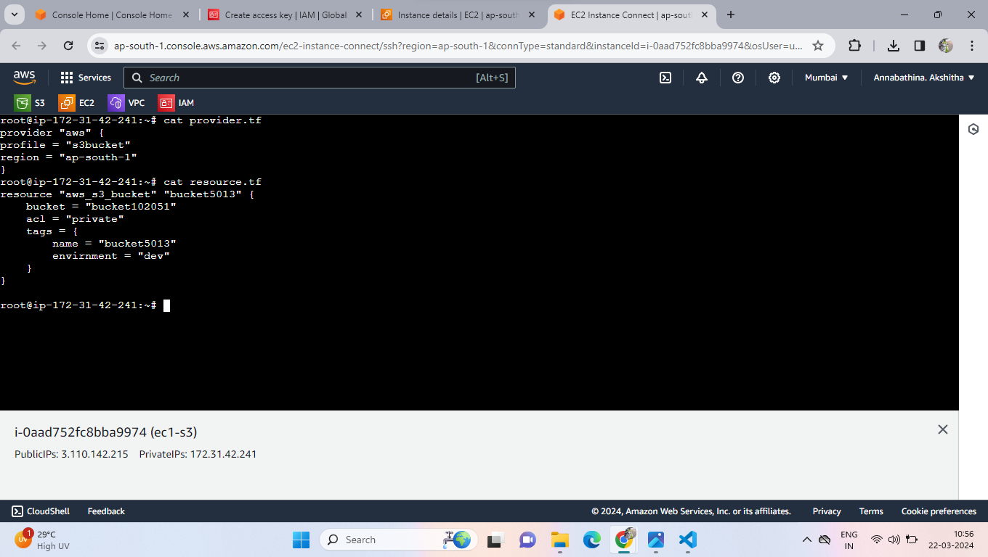

* After writing the script then execute the code in terraform commands are

Terraform init

Terraform plan

Terraform apply

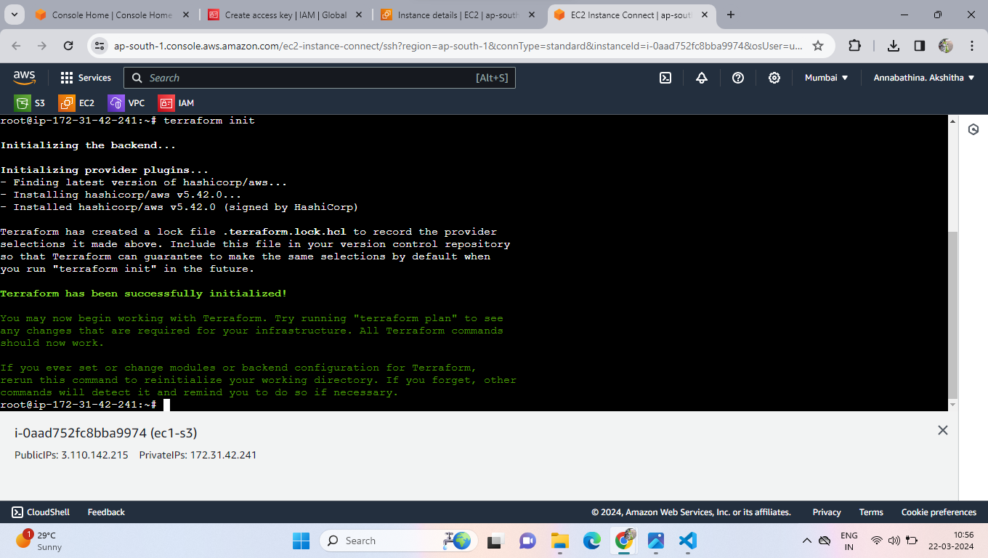

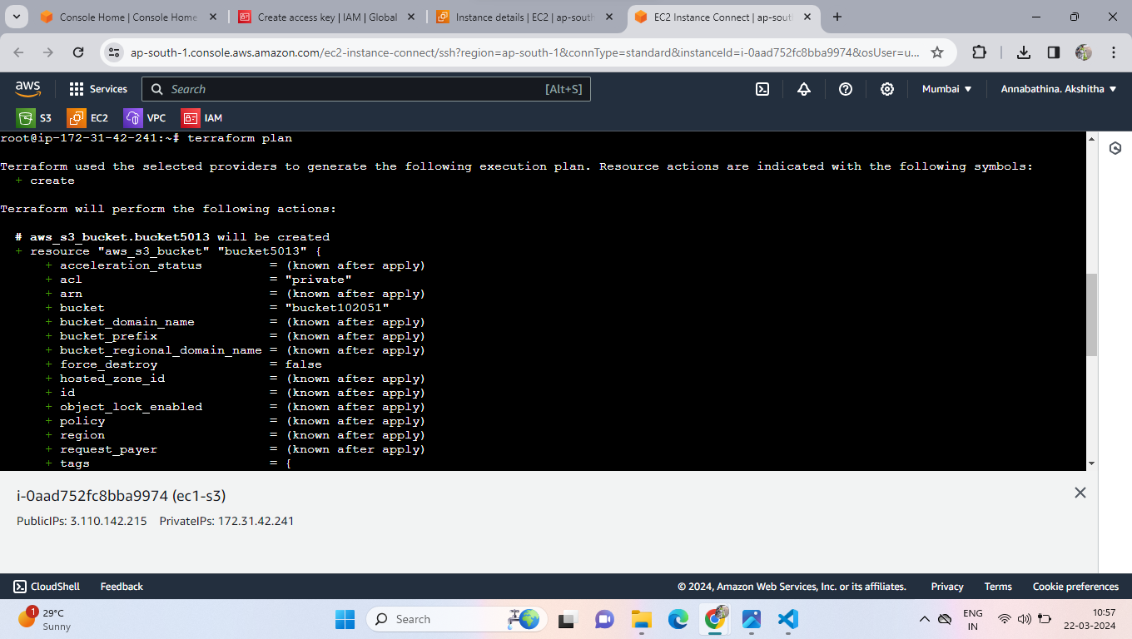

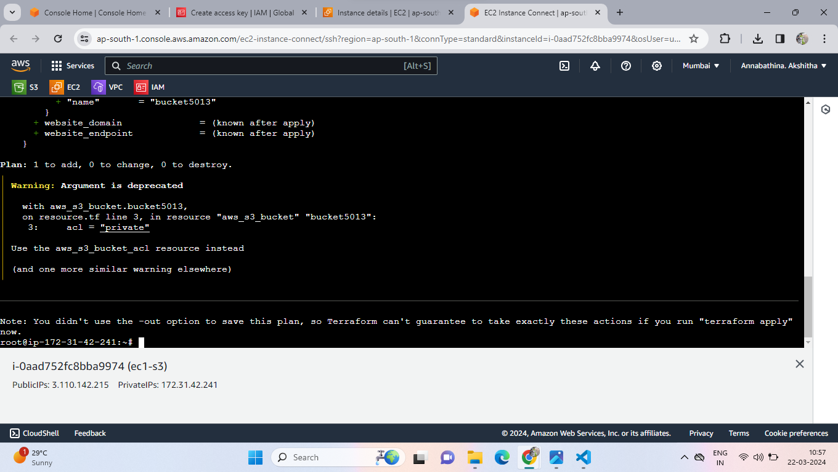

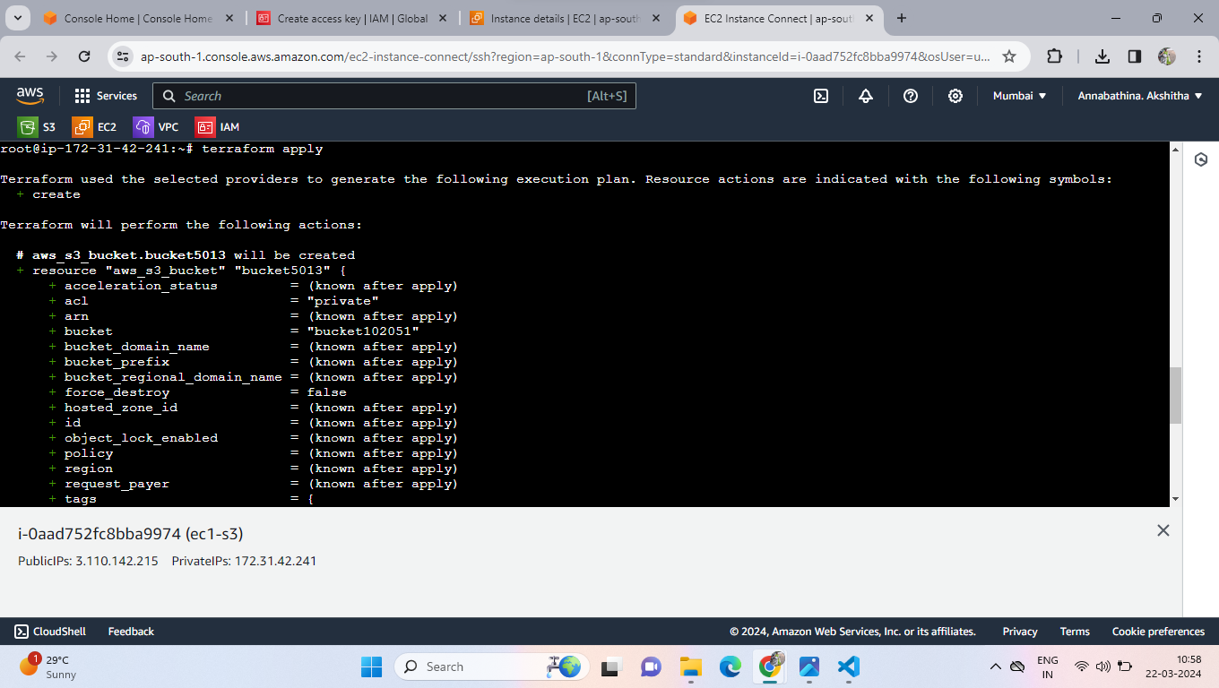

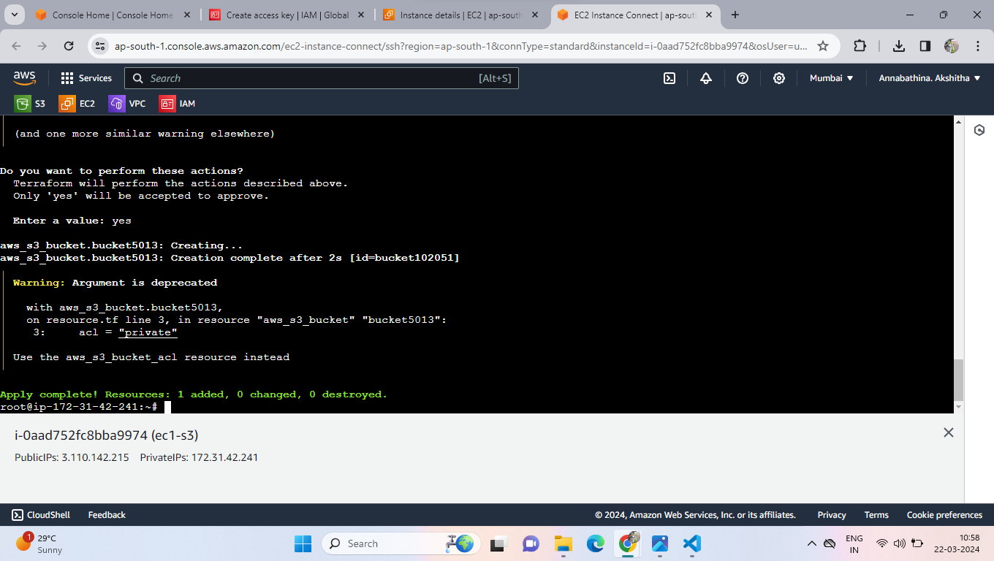

* Now go to S3 then see the bucket created or not

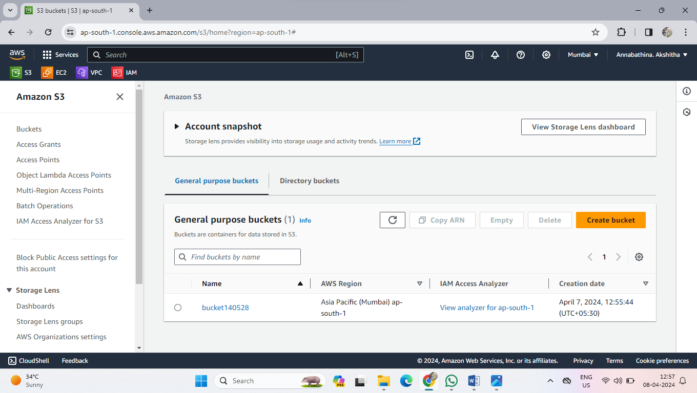

* Now upload files into created bucket
* Create create file and write something in that file and copy the file path and paste into the source in object.tf
* create one object.tf file write script for objects upload then “**terraform apply –auto-approve**” the command.

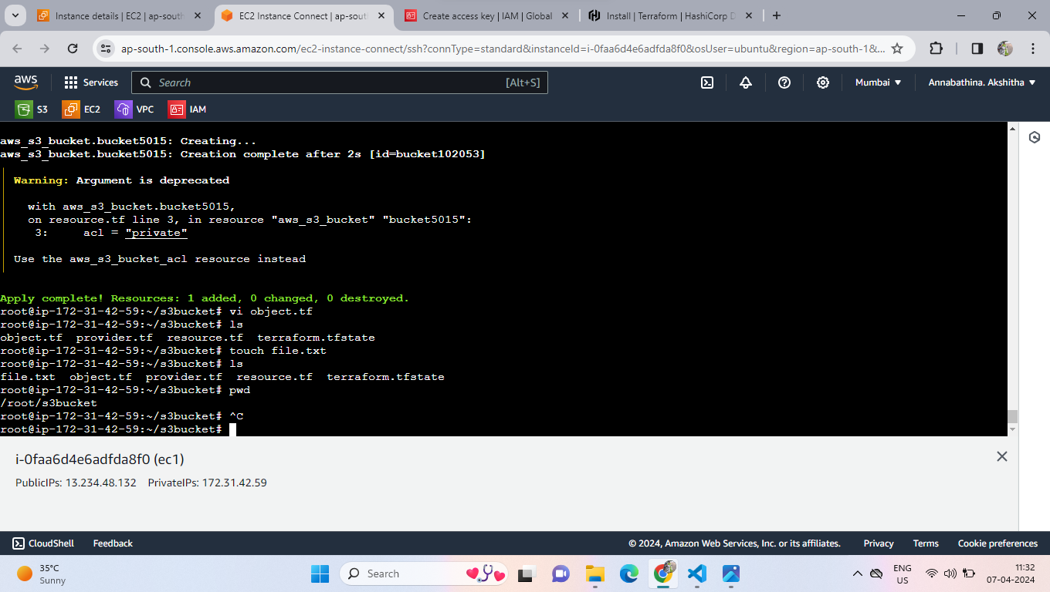

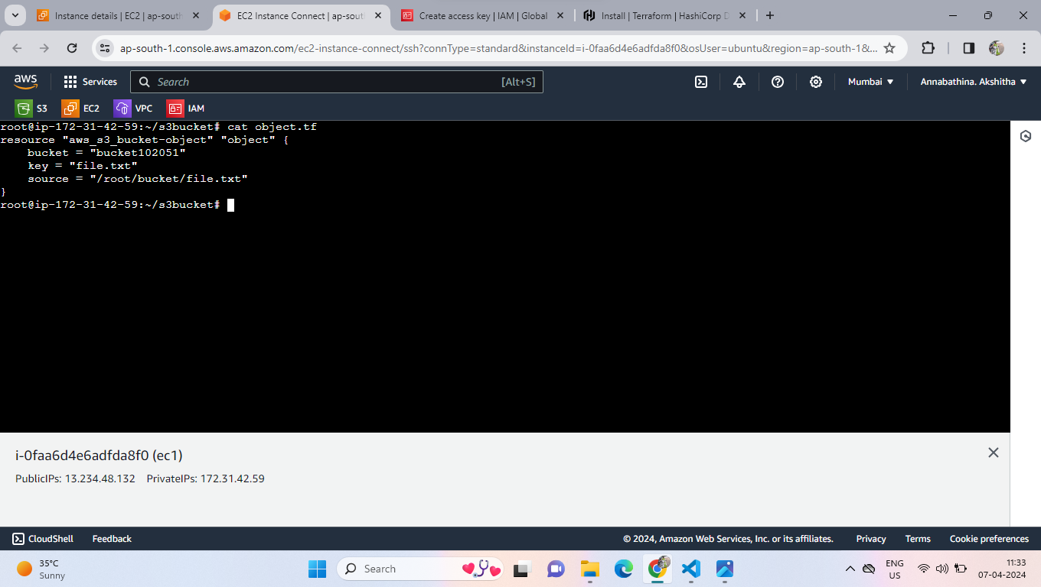

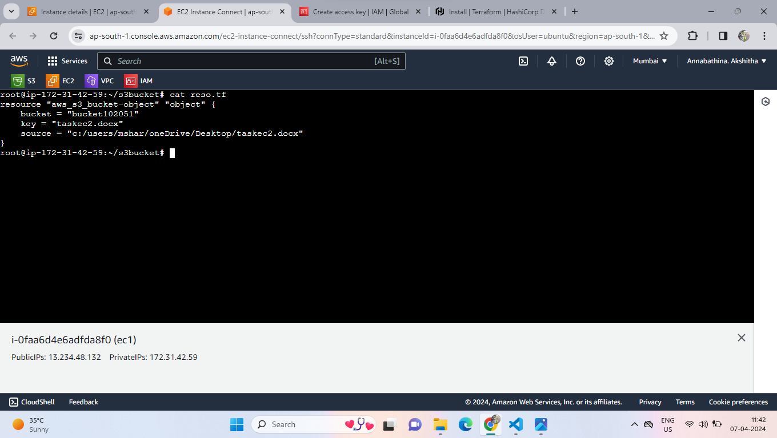

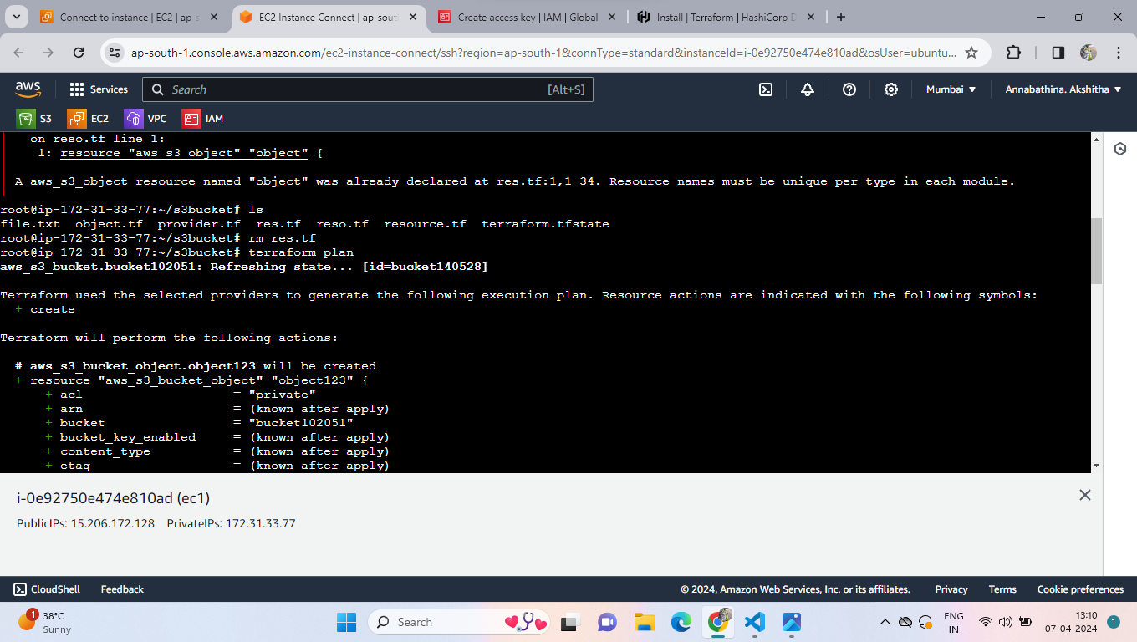

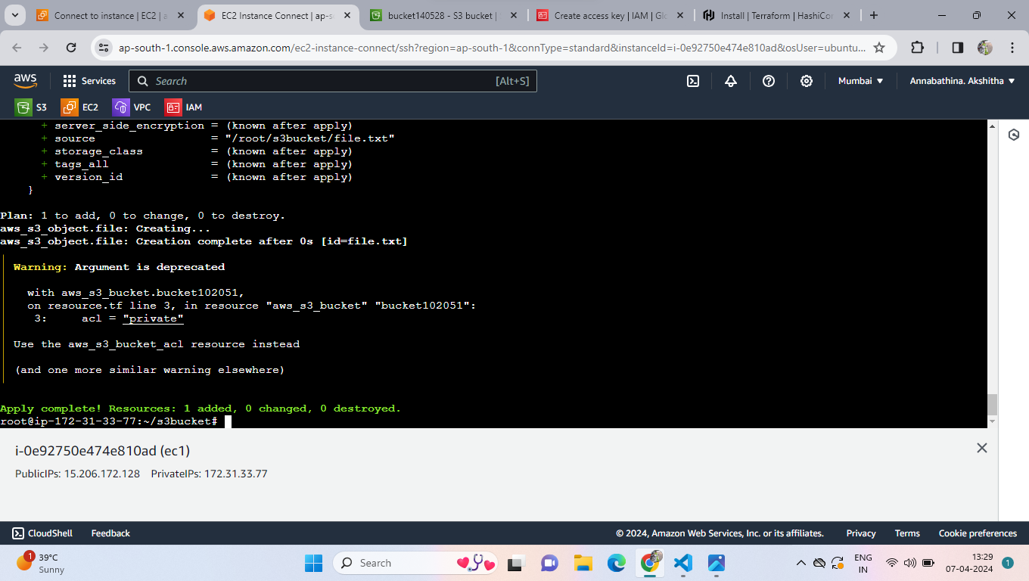

* Now we can see the file in the bucket.

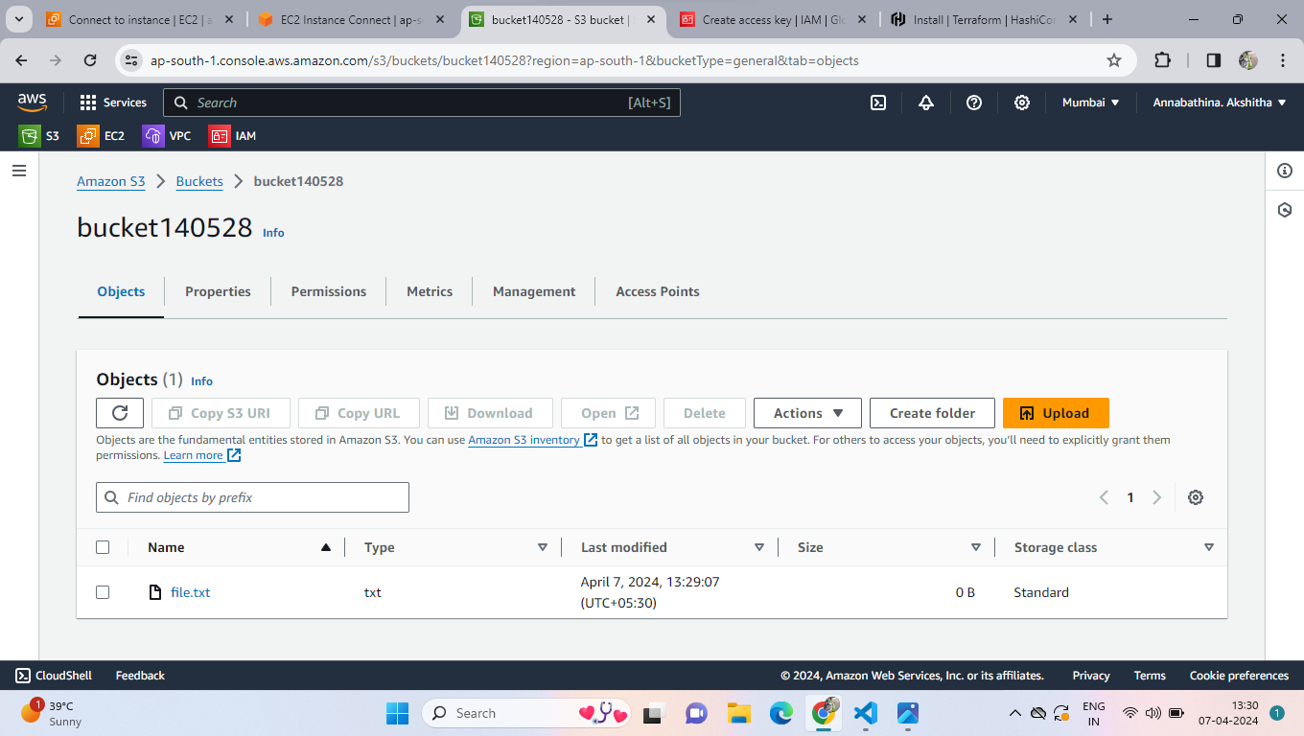

**\*\*\*\*\*\*\*\*\*\*\*\*\*\*\*\*\*\*\*\*\*\*\*\*\*\*\*\*\*\*\*\*\* ** END \*\*\*\*\*\*\*\*\*\*\*\*\*\*\*\*\*\*\*\*\*\*\*\*\*\*\*\*\*\*\*\*\*\*\*\*\*\*\***